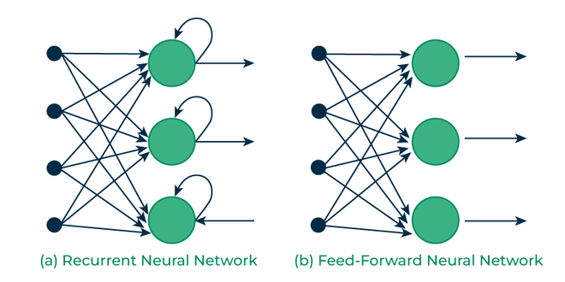

**What I Understand About RNNs (Recurrent Neural Networks):**

1. **RNNs are designed for sequential data**  
   They process input data step by step, making them great for tasks like time series, language modeling, or speech recognition.
2. **They have memory**  
   RNNs keep track of previous inputs using a hidden state that gets updated at each time step. This helps them remember information from earlier in the sequence.
3. **Same weights are reused**  
   Unlike feedforward networks, RNNs use the same weights at every time step, which reduces the number of parameters and makes training more efficient.
4. **They struggle with long sequences**  
   Standard RNNs often forget long-term dependencies due to issues like vanishing gradients.
5. **Variants like LSTM and GRU were created to fix this**  
   Long Short-Term Memory (LSTM) and Gated Recurrent Unit (GRU) networks have special gates to help them remember important information for longer.
6. **They take input step by step and produce output step by step**  
   For example, in text generation, each word is predicted based on previous words.